Write an Java application with the following requirements:
- Use JDBC to store data.
- Implement functions related to buttons

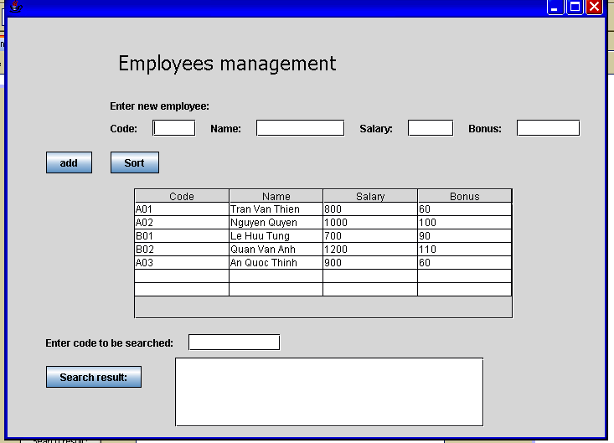

-ComboBox: Code, Name,Salary
-RadioButton: Asc, Des

